**22. Write a program to demonstrate XML and XML schema assertions in JMeter.**

**XML Assertions:**

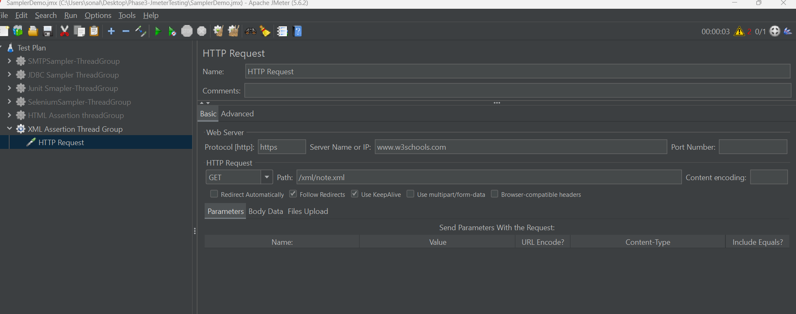

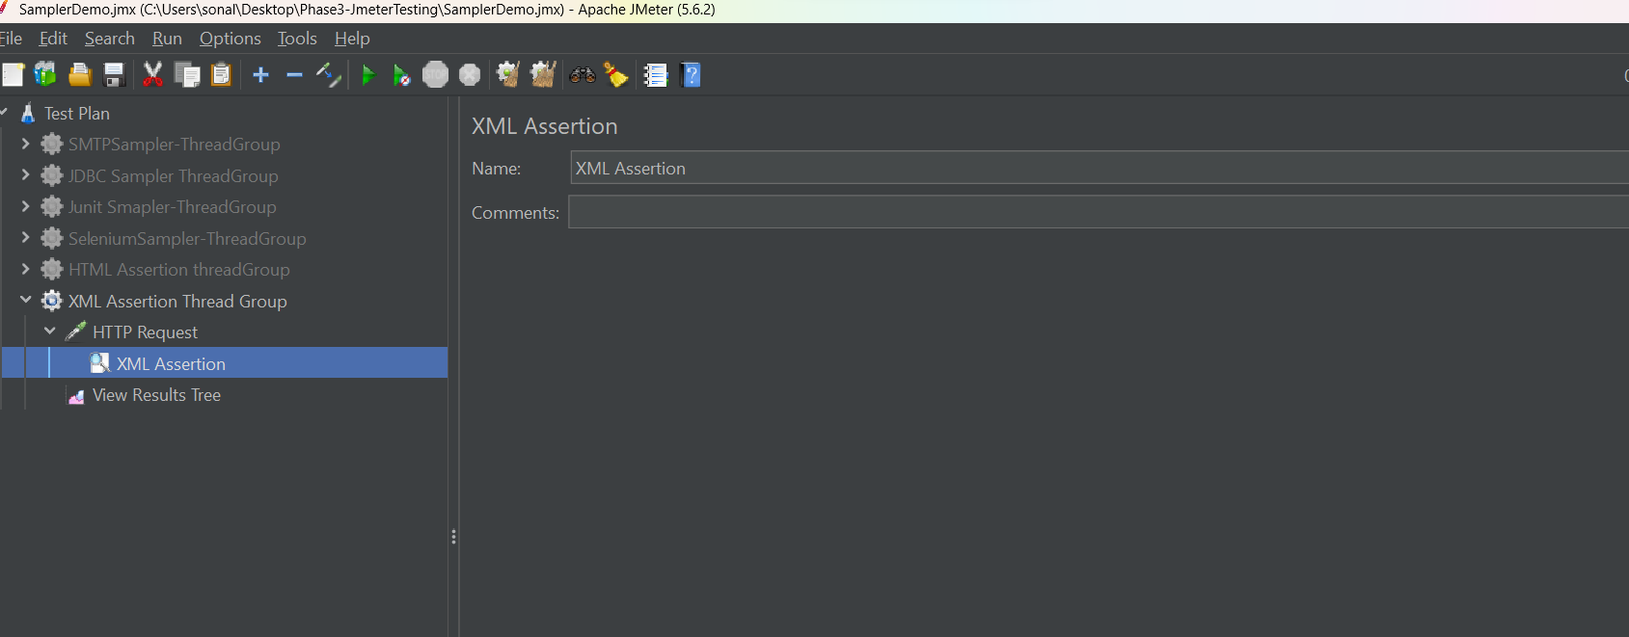

The assertion will just check if the response of the https request is an XML or not.

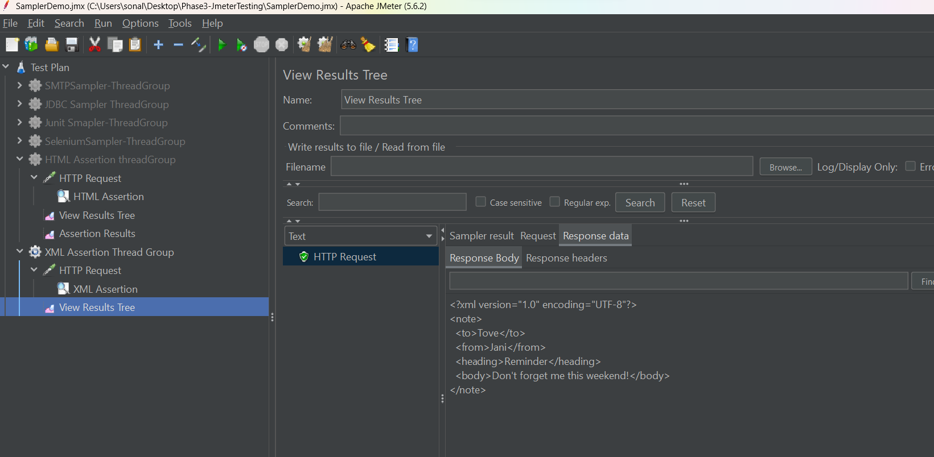

**XML Schema Assertions:**

XML schema Assertion

It just check if xml response is having a schema or not

Take you XML file and generate the schema for it:

<note>

<to>Tove</to>

<from>Jani</from>

<heading>Reminder</heading>

<body>Don't forget me this weekend!</body>

</note>

<?xml version="1.0" encoding="utf-8"?>

<!-- Created with Liquid Technologies Online Tools 1.0 (https://www.liquid-technologies.com) -->

<xs:schema attributeFormDefault="unqualified" elementFormDefault="qualified" xmlns:xs="http://www.w3.org/2001/XMLSchema">

<xs:element name="note">

<xs:complexType>

<xs:sequence>

<xs:element name="to" type="xs:string" />

<xs:element name="from" type="xs:string" />

<xs:element name="heading" type="xs:string" />

<xs:element name="body" type="xs:string" />

</xs:sequence>

</xs:complexType>

</xs:element>

</xs:schema>

Save the XSD file in jmeter🡪bin🡪examples

